**Project 1 Task:**

You are asked to create a database design that will store information for the business problem described below.

The business problem lists and describes the data in a way that made sense to me. In no way is it intended to suggest any design choices. It is up to you to create a valid design.

**Solution: Airline Database Design**

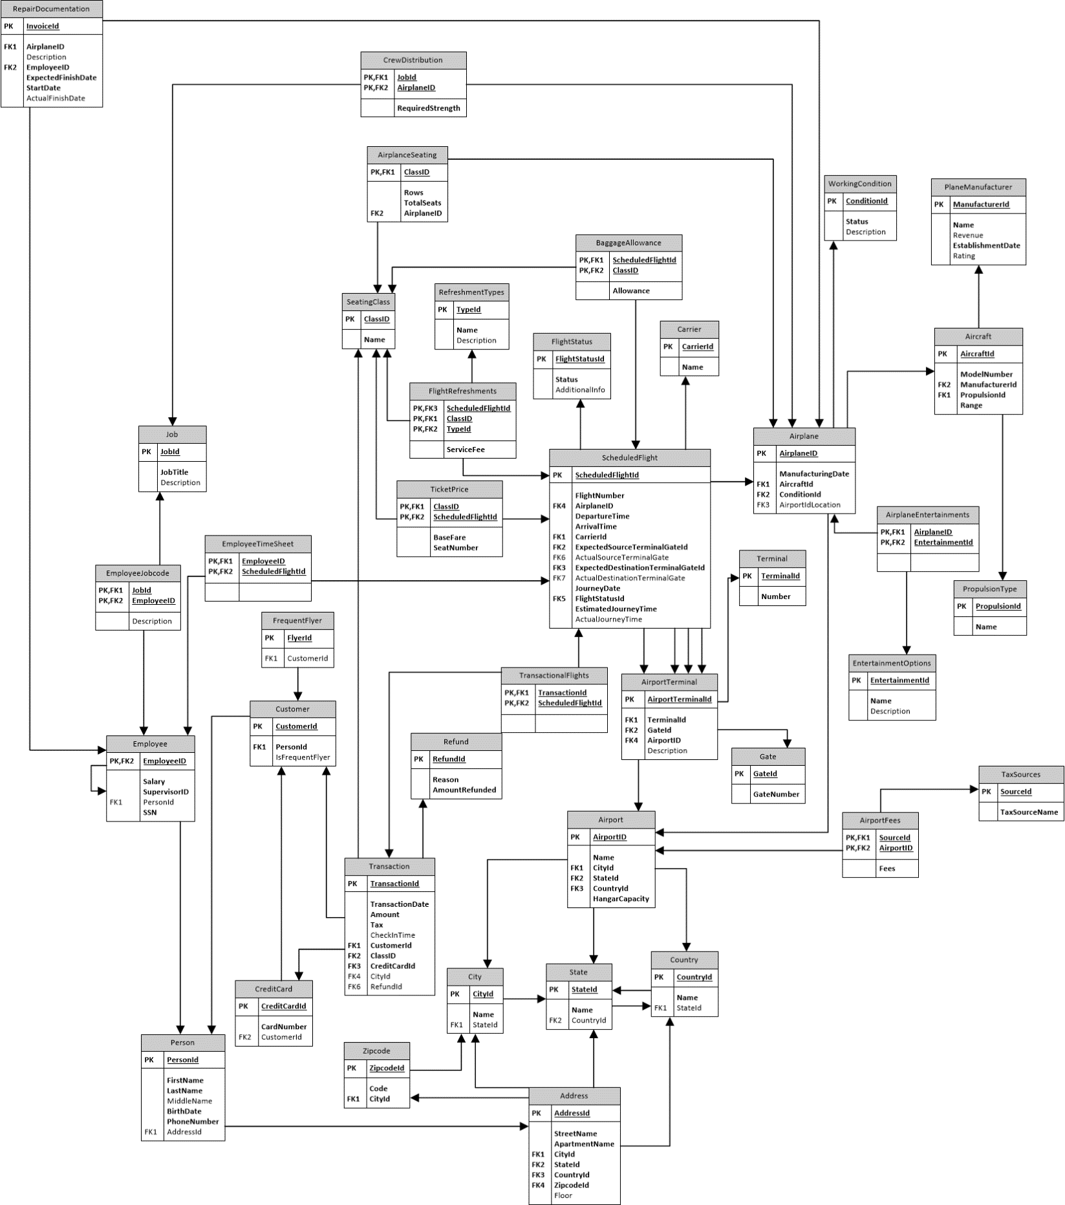

**Design Considerations for action points:**

1. Which terminal(s) are available to us?

* It will be conveyed through **linking table “AirportTerminal”**

1. Which planes can land here?, Actual planes that are currently at this airport?

* Planes that are scheduled are considered to land at the airport through ScheduleFlight table (ActualSourceTerminalGate). And planes that are under maintenance are associated through Airplane table (AirportLocation foreign key).

1. **Capacity** of a particular airplane specific to seating class can be make out through AirplaneSeating linking table. Here “TotalSeats” correspond to seating capacity of the entire class for that particular airline. IndividualSeats per row is a calculated field from the same linking table.
2. **Crew** that is working for a flight is described through EmployeeTimeSheet linking table. Similarly the linking table **CrewDistribution** determines the total strength of people required to operate the plane as per the job title.
3. **Similarly** other linking tables are also used to identify many to many relationships.